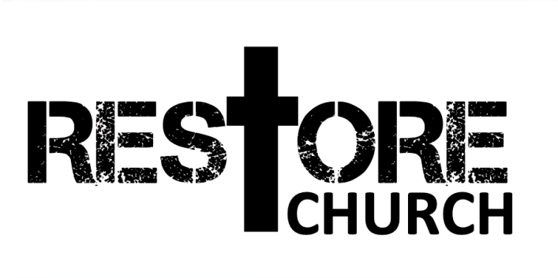
THE CHURCH NEEDS…
WWW.MYRESTORE.CHURCH

MEMORY VERSE: 1 Corinthians‬ 12:12, 15‬ ESV‬‬‬‬
“For just as the body is one and has many members, and all the members of the body, though many, are one body, so it is with Christ...If the foot should say, “Because I am not a hand, I do not belong to the body,” that would not make it any less a part of the body.”
‬‬
THREE NEEDS OF THE CHURCH

THE CHURCH NEEDS _________________
___________________________________________________________________________________________________________________________________________________

THE CHURCH NEEDS _________________
___________________________________________________________________________________________________________________________________________________

THE CHURCH NEEDS _________________
___________________________________________________________________________________________________________________________________________________

TWO ESSENTIAL RESPONSES:

COMMIT TO A _______________ _______________
__________________________________________________________________________________________________

_________ __________ THAT COMMITTMENT
___________________________________________________________________________________________________________________________________________________

REFLECTION QUESTIONS

- What gifts has God given you? Be broad in your response. What are some ways God has developed or tested those gifts over time? (If you feel like you have no gifts, ask someone who knows you well to speak into you. They might see what you don’t.)

- How can you become more united in the Body of Christ? What can you be actively doing to grow in unity with those around you? (This can be anything from praying with your brothers & sisters in Christ to surrendering to Jesus.)

- Write in Next Step section below what your next step is to either commit or to serve out your commitment. Make sure to share with you GC or Disciple-Maker so you can have some accountability!

MY NEXT STEP TODAY IS (WHAT IS THE WISE THING?):
___________________________________________________________________________________________________________________________________________________

